
Education Core System

Prepared By:
• Muhammad Abdullah Zia (Roll No: F2024065219)
• M. Umer (Roll No: F2024065238)

Project Scope:

Objective:
To develop a centralized education management system that efficiently manages student, teacher, and admin data, including attendance, test results, fees, scholarships, and user accounts. The system ensures data consistency, easy access to academic records, and streamlined administration processes.
Scope Includes:
- Managing student profiles, courses, sections, and attendance.
- Recording and analyzing test results for students.
- Managing teacher data, total students, and their attendance records.
- Admin functionalities:
  - Adding and managing student accounts
  - Viewing student details
  - Fee collection and scholarship management
  - Class/section assignment
  - Overall user account management
- Search functionality for students, teachers, and classes.
- Account-based login with role distinction: Student, Teacher, Admin.
Scope Limitations:
- The system is focused on academic administration only (does not include hostel management or transport management).
- Reports and analytics are limited to attendance, results, and fee status.

Functional Requirements:

1. User Management:
- Login and Registration
  - Students, teachers, and admins must be able to log in using secure credentials.
  - Role-based registration and login ensures proper access to system functionalities.
- Role-Based Access Control
  - Students can access only their own profiles, attendance, and results.
  - Teachers can access student lists under their supervision and mark attendance or test results.
  - Admins have full access to manage users, classes, and academic operations.
- User Account Management
  - Admins can register new users (students/teachers) and assign roles.
  - Update or deactivate existing user accounts.
  - Password reset and account recovery features.
2. Student Management
- Profile Management
  - Students can view and update personal information such as name, section, and enrolled courses.
- Attendance Management
  - Students’ daily attendance can be recorded by teachers.
  - Students can view their own attendance history and summary.
- Test Results
  - Record and maintain test results for each student.
  - Students can view grades, progress, and academic performance reports.
- Financial Management
  - Track fees paid and pending.
  - Record scholarships awarded and their status

3. Teacher Management
- Student Supervision
  - View the list of students assigned to them.
  - Access individual student attendance and test results.
- Attendance Recording
  - Mark attendance for all assigned students.
  - Generate attendance reports for their classes.
- Academic Management
  - Enter and update test results for students.
  - Monitor students’ academic performance.
- Search and Reporting
  - Search students by name, section, or course.
  - Access filtered reports for attendance and results.

4. Admin Management:
- User and Account Management
  - Add, update, or delete student and teacher accounts.
  - Assign roles and manage login credentials.
- Class and Section Management
  - Assign students to specific classes and sections.
  - Manage teacher-class assignments.
- Fee Collection and Scholarship
  - Collect fees from students and update payment records.
  - Allocate and manage scholarships.
- Data Access and Reporting
  - View detailed records for all students and teachers.
  - Generate reports for attendance, test results, and fees.

5. Academic Operations
- Attendance Management
  - Daily marking, editing, and reporting of attendance.
  - Access attendance history for students and classes.
- Test Results Management
  - Input, update, and track test results for all students.
  - Generate grade reports and performance analytics.
- Search Functionality
  - Students, teachers, and admins can search for records by name, section, class, or course.

Non-Functional Requirements:
- Usability
  - Simple and intuitive interface for students, teachers, and admins.
  - Minimal training required for system use.
- Performance
  - Quick response for queries like search, attendance, and test results.
  - Efficient data retrieval and processing.
- Reliability
  - System must ensure accurate and consistent academic records.
  - Backup and recovery mechanisms for data safety.
- Security
  - Role-based access control to prevent unauthorized access.
  - Password-protected accounts for all users.
  - Secure storage of sensitive data (fees, test results).
- Maintainability
  - Modular code structure for easy updates and feature addition.
  - Clear separation between student, teacher, and admin modules.
- Scalability
  - Able to handle large numbers of students, teachers, and courses.
  - Extendable to add additional modules like transport, hostel, or library in the future.

Work Breakdown Structure (WBS):
- 1. Requirement Analysis
  - 1.1 Gather Functional Requirements
  - 1.2 Gather Non-Functional Requirements
  - 1.3 Analyze Scope and Limitations
- 2. System Design
  - 2.1 Database Design
    - 2.1.1 Tables: Students, Teachers, Admin, Attendance, Fees, Scholarships
    - 2.1.2 Relationships: Student-Class, Teacher-Student, Admin-User
  - 2.2 UI/UX Design
    - 2.2.1 Login Screens
    - 2.2.2 Dashboard for Students, Teachers, Admin
    - 2.2.3 Forms for Attendance, Results, Fees
- 3. Module Development:
  - 3.1 Student Module
    - 3.1.1 View and Update Profile
    - 3.1.2 Attendance Marking
    - 3.1.3 View Test Results
    - 3.1.4 View Fees and Scholarships
  - 3.2 Teacher Module
    - 3.2.1 View Assigned Students
    - 3.2.2 Mark Attendance
    - 3.2.3 Enter Test Results
    - 3.2.4 Search Students
  - 3.3 Admin Module
    - 3.3.1 Add/Update/Delete Students & Teachers
    - 3.3.2 Assign Classes/Sections
    - 3.3.3 Fee Collection and Scholarship Management
    - 3.3.4 Manage User Accounts
- 4. Integration & Testing
  - 4.1 Integrate Student, Teacher, Admin Modules
  - 4.2 Functional Testing
  - 4.3 Performance Testing
  - 4.4 Security Testing

- 5. Deployment
  - 5.1 Setup Production Environment
  - 5.2 Deploy System
- 6. Documentation & Training
  - 6.1 Prepare User Manuals
  - 6.2 Training Sessions for Admins, Teachers, Students

Gantt chart:

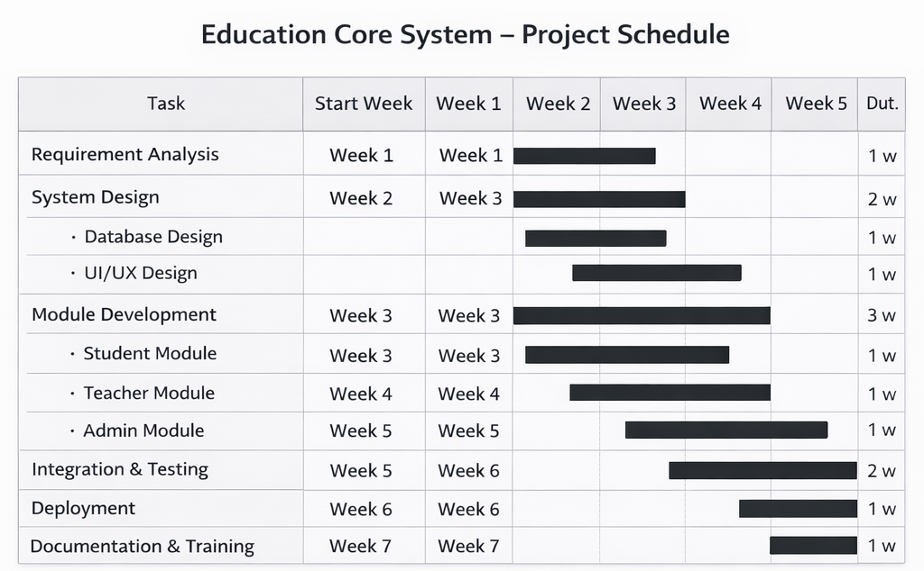

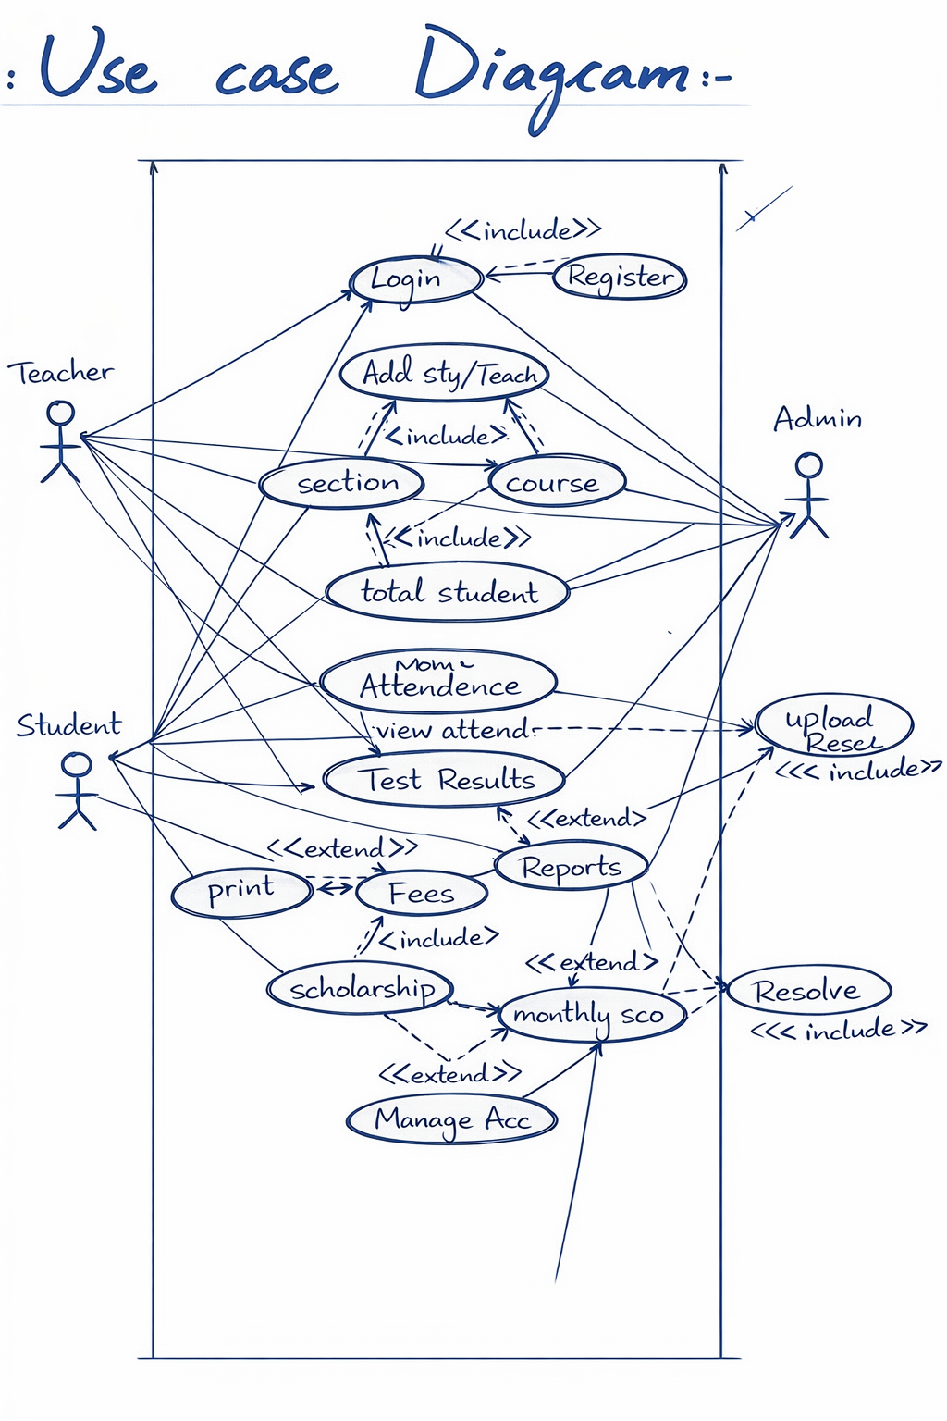

UML Class Diagram:
